# A:\CBHE-factori\aa-starter\Factori_soumis\communication\logo\Logo Factori 4.0.png

# From Automation and Control Training to the Overall Roll-Out of Industry 4.0 Across South-East Asian Nations

# (ASEAN FACTORI 4.0)

**PROJECT No. 609854-EPP-1-2019-1-FR-EPPKA2-CBHE-JP**

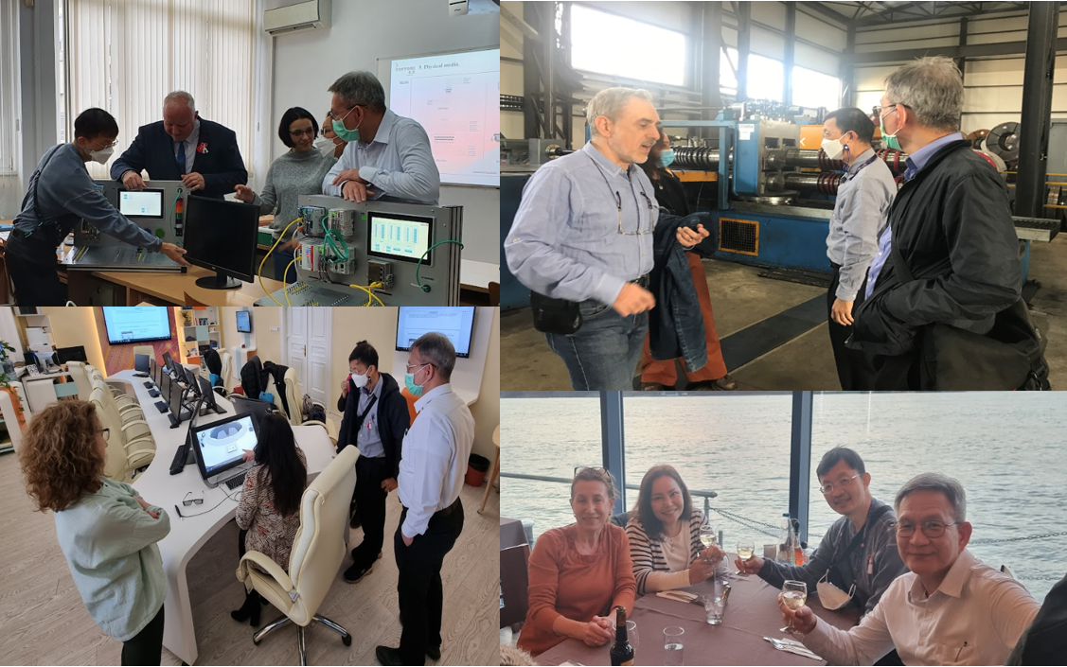**Training in EU at The University of Ruse “Angel Kanchev,” Bulgaria (PPP-Train1) on March 5-April 2 2022**

Training in EU, a collaborative training, continues between the University of Ruse “Angel Kanchev”, Bulgaria and Chulalongkorn University, aiming to foster mutual growth and cooperation. Trainers from the University of Ruse are Prof. Plamen Ivanov Daskalov PhD. from Department of Automation and Mechatronics, Associate Prof. Tsvetelina Georgieva PhD. from Department of Automation and Mechatronics, Associate Prof. Plamen Zahariev PhD. From Department of Telecommunications, Associate Prof. Georgi Hristov, PhD. from Department of Telecommunications, Associate Prof. Nina Bencheva PhD. from Department of Telecommunications. Delegates from Chulalongkorn University are Prof. Paisan Kittisupakorn PhD. from Department of Chemical Engineering, Prof. David Banjerdpongchai PhD. from Department of Electrical Engineering, and Instructor Sirikanya Singcuna from Department of Chemical Engineering.

The goal of Training in EU is to prepare Chulalongkorn University teachers responsible for the Center of Excellence. It involves offering them an initial understanding of the PLC knowledge level among CU teachers. Subsequently, CU teachers will be engaged in translating the pedagogical material document from this intensive training. This translation aims to facilitate the future implementation of practical laboratory work.

The exchange of knowledge, skills, and expertise starts with the EU providing training for CU in Europe. These trainings aim to equip CU with fundamental knowledge by receiving fundamental PLC training in the EU, including visits to PLC manufacturing facilities.